**Ordering Bundles - ShopCPR**

Step 1: Navigate to ShopCPR.Heart.org

Step 2: Find the desired bundle and select ‘View Details’

Step 3: Select ‘View Included Products’

Step 4: Select the quantity and select ‘Add to Cart’

**Note: To view the included products of the bundle, hover over the ‘Included Products’ button

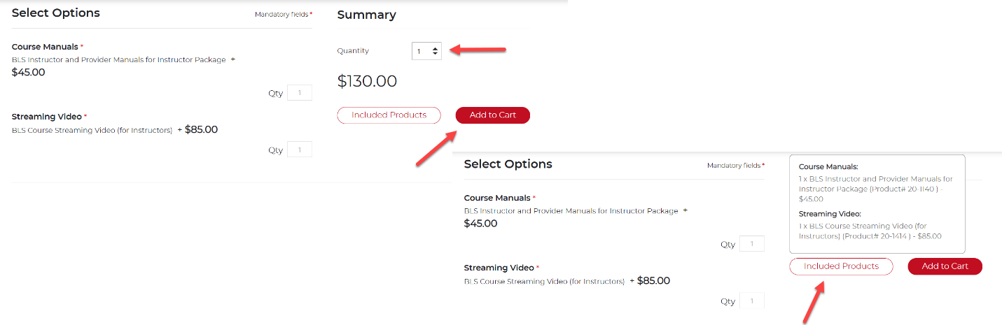

Step 5: Continue through the checkout process

***Note: If you are purchasing on behalf of an Organization, you can enter your purchase code during the checkout process. By entering the purchase code, any eBook or eLearning inventory will transfer directly into your Training Central account.

Step 6: Upon checkout, you will be able to access your digital inventory immediately by selecting ‘View Included Products’ and selecting the resulting prompt

